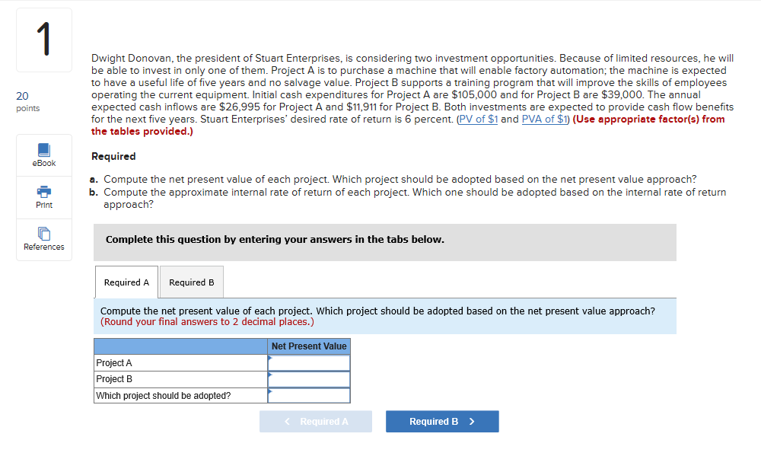
Required
a).Compute the net present value of each project. Which project should be adopted based on the net present value approach?
Solution
 |  | Project A |  | Project B
Year | P.VF@6% | Cash flow | P.v. | Cash flow | p.v.
0 | 1 | (105,000) | (10500) | (39000) | (39000)
1-5 | 4.2124 | 26995 | 113714 | 11911 | 50174
 |  | N.P.V(A) | 8714 | N.P.V(B)= | 11174
Based on the above calculation, Project B should be selected as its Net present Value is higher.


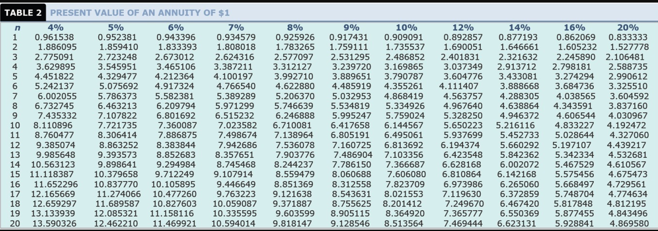
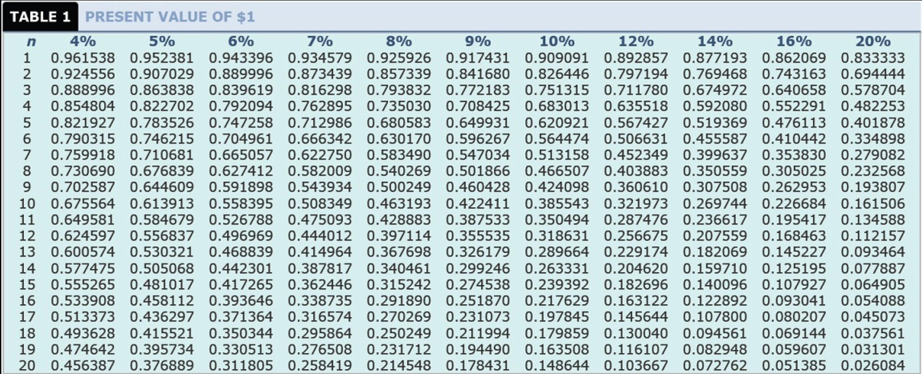
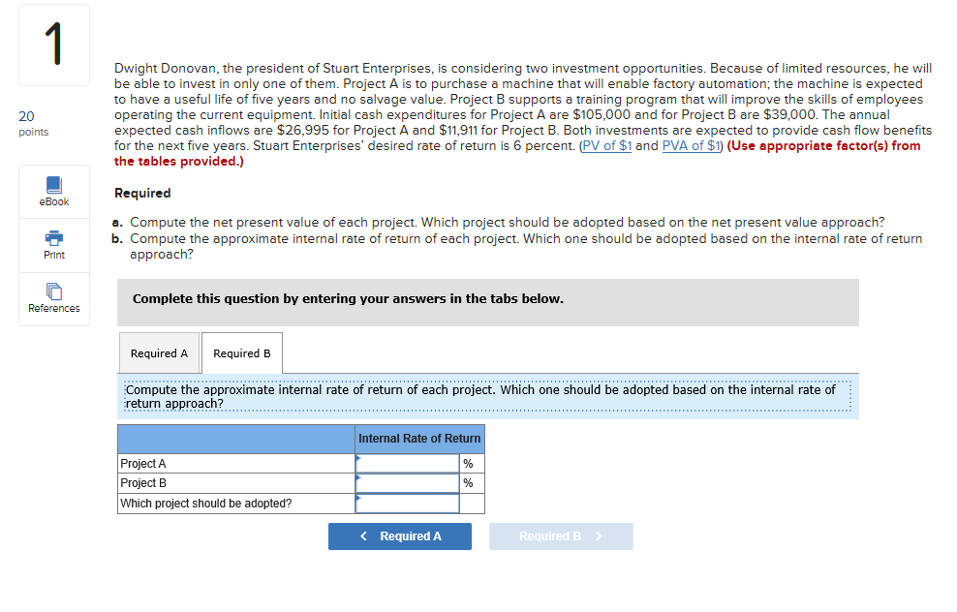
b).Compute the approximate internal rate of return of each project. Which one should be adopted based on the internal rate of return approach?
Project A
Year PV.F @8.5% Cash Flow P.V P.V.F@9.5% P.V
0 1 (105000) (105000) 1 (105000)
1-5 3.9906 26995 106376 3.8397 103653
$1376 $ (1347)

Therefore IRR_{A}=8.5%+ [1376-0] / [1376-(1347)] X1%
= 9%

Project B
Year P.V.F @15.5% Cash flow P.V P.V.F %16.5 P.V
0 1 (39000) (39000) 1 (39000)
1-5 3.3129 11911 39460 3.2365 38550
$ 460 $(450)

Therefore IRR_{B} = 15.5% + [460-0] /[460-(450)] X 1%
=16%
Based on the above, Project B should be selected as its IRR_{B} ˃IRR_{A}

